**Design animation of Mortal Kombat**

Mortal Kombat

Animation of Mortal Kombat is created by Flash with many different frames in different layers. The programmer first created background in a layer with many frames, then created the other layers for the movements of Johnny Cage and Scorpion. The next things was create the Blood bar, which when both of characters fight will be show the different blood left. There are three different levels that to complete the game as an animation. The Mortal Kombat animation involved with many different texts to direct viewer to well understand this animation.

The animation will use software Flash to create different cel layers to support animators to success create animation. The cel layers created with different frames, and each frame objects slightly different to composite the images, thereby to meet the plan to create the animation. The animation of Mortal Kombat will involves with different cel layers:

* Cel layer – Background
* Cel layer – Character movements (Images)
* Cel layer – Texts

Structure diagram

**Story scene1**

**Story scene2**

**Story scene3**

**Introduction**

**End**

**Start**

Storyboard of Animation Name: Mortal Kombat

**Background**

The background used one of image that got from Internet of Mortal Kombat game. The background will be displays on the cream until the animation finished, which it used many frames to achieve this in a layer named as Background.

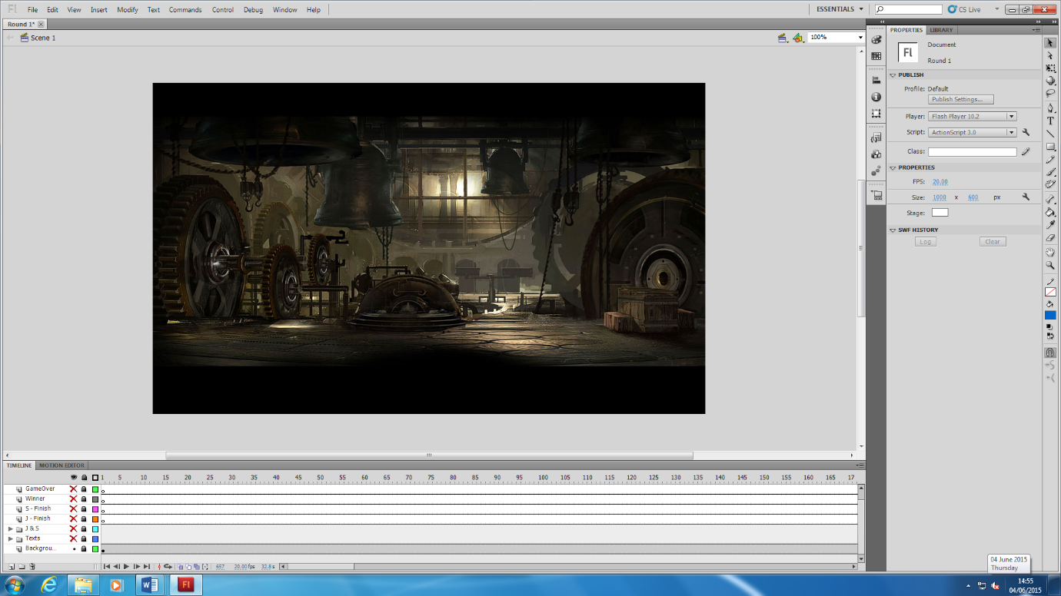

**Texts**

There are some layers for the texts that display on the scream as the information that allows viewer and understand about this animation. The texts including:

* The characters names Johnny Cage and Scorpion
* Round 1 – fight
* Against sign (v.s.)
* Count down numbers
* Blood boxes
* Characters movements
* The winner
* Game Over
* The next step

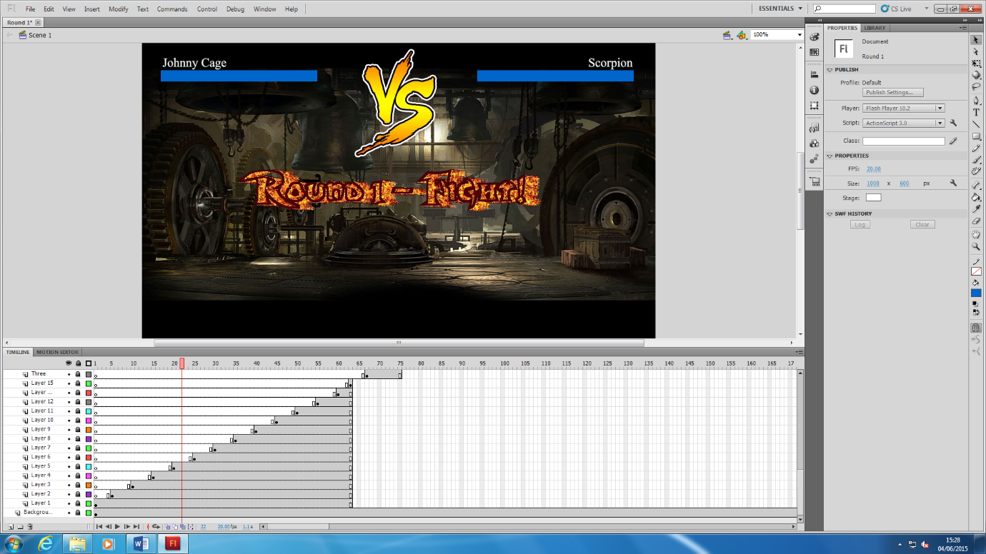

*The characters names Johnny Cage and Scorpion*

Both characters Johnny Cage and Scorpion names are display on the scream until the animation finish.



*Round 1 – fight*

The texts of round1-fight is a message that introduce the viewer about what is going on in this stage and set it on the centre, which with many frames thereby combine these into one image that displayed on the scream as an animation itself.



*Against sign (v.s.)*

The image of the VS as the message that display on the scream until the end of this animation.

*Count down numbers and fight*

There are have numbers and fight sign will display on the scream before the characters start to fight, which guide viewer the fight about start.

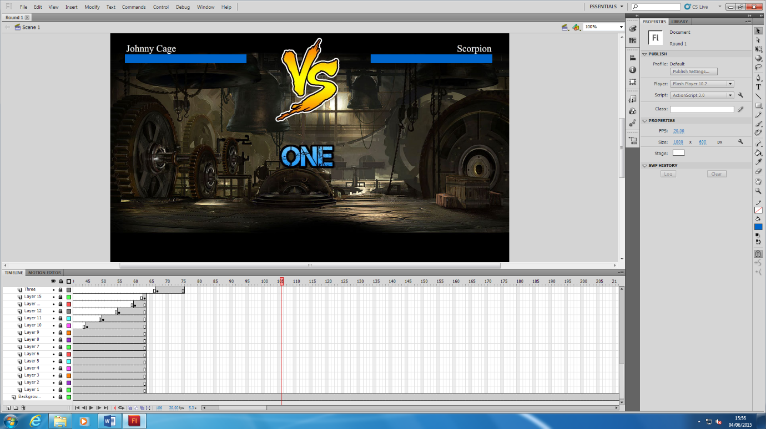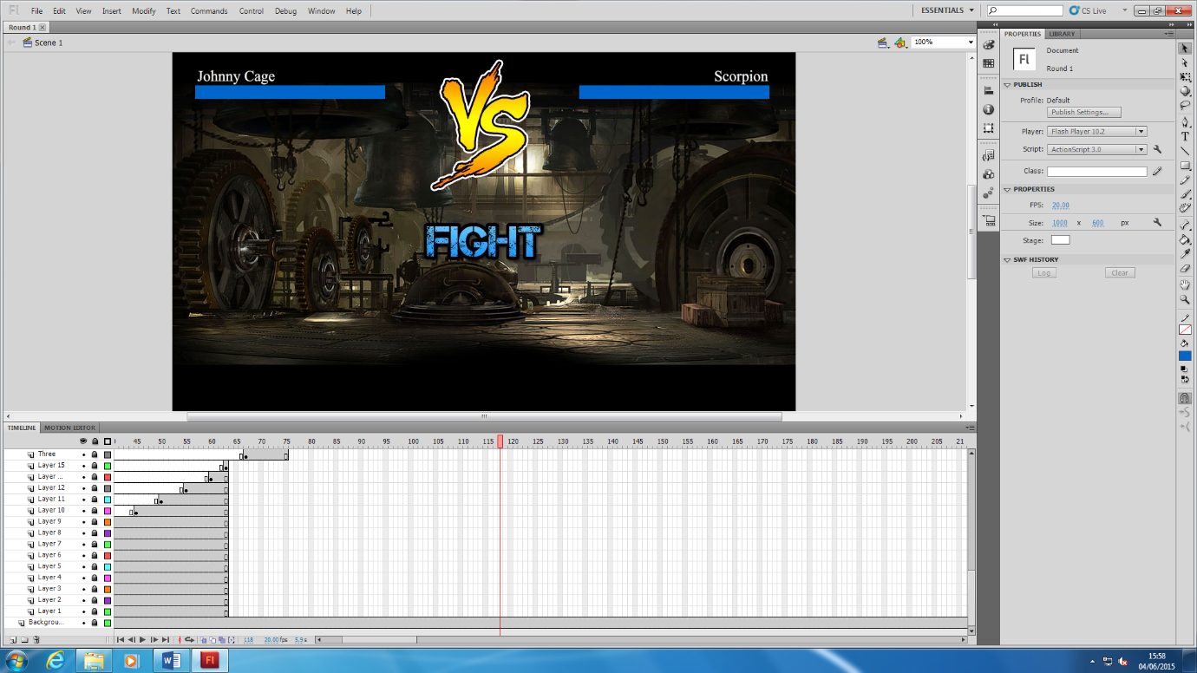

*The winner*

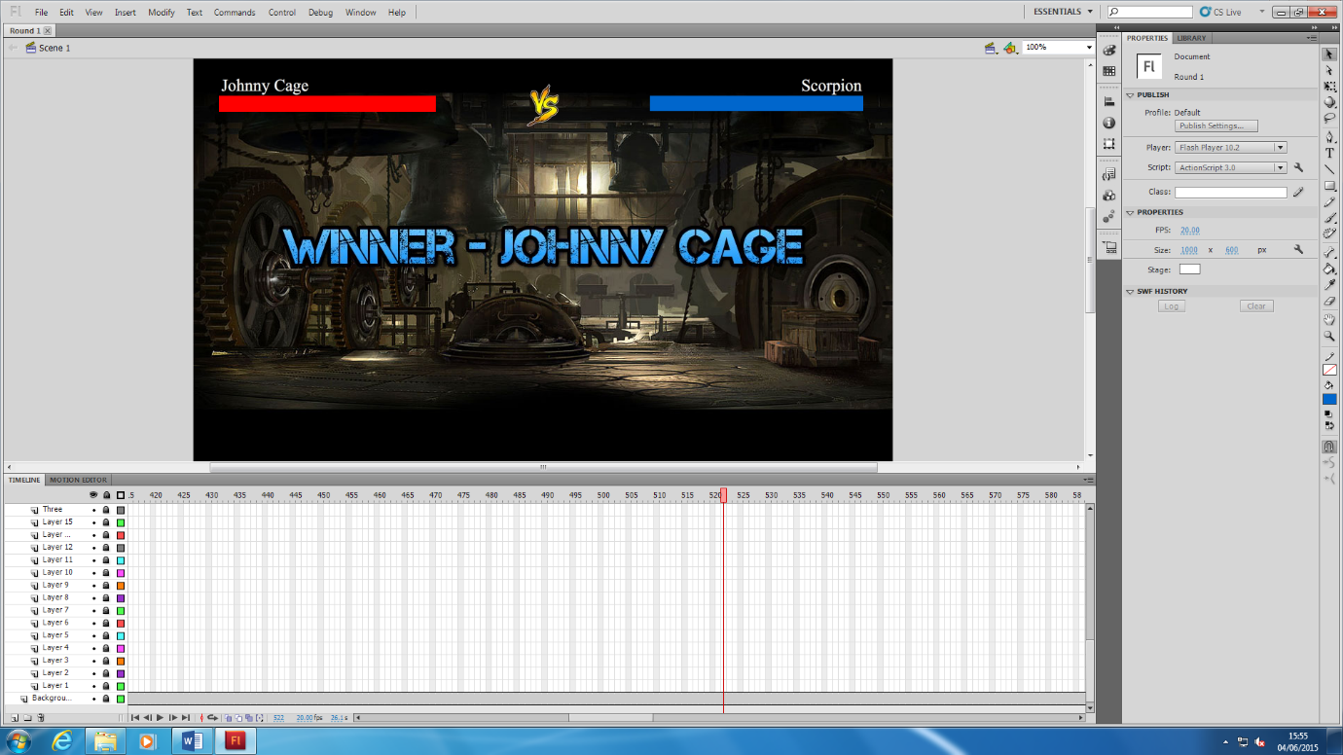When the animation comes to the end, there will be winner and for this section that text of the winner will be display on the scream about few second as guide the viewer the winner.

*The next step*

After the text winner shown, the text of Next will display on the scream also about few second as guide the viewer what will happen in the next.

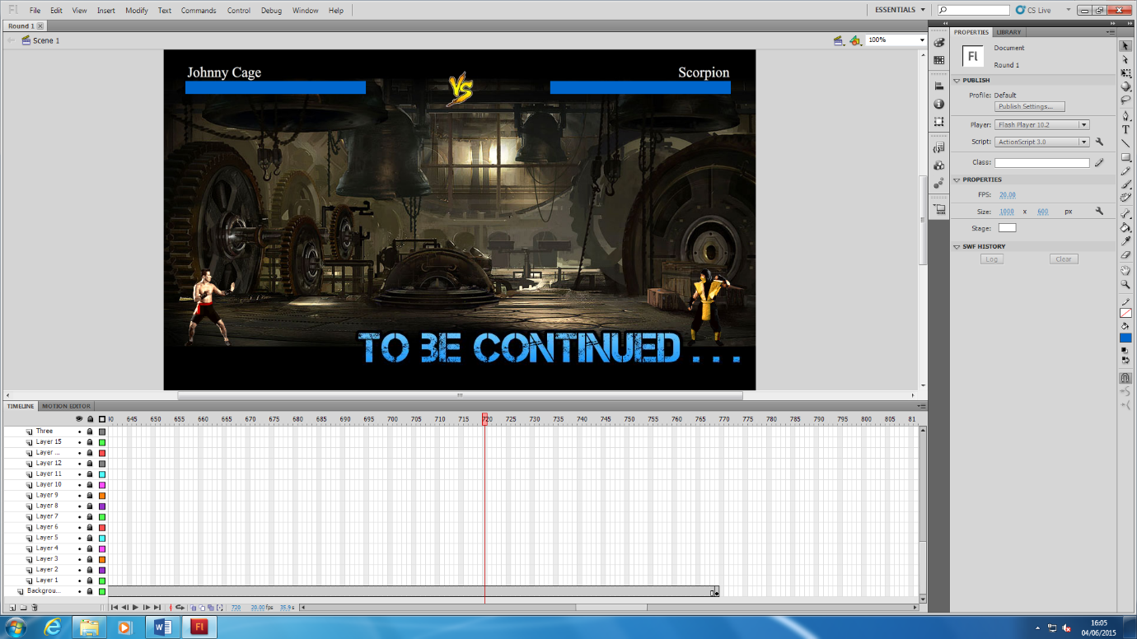

*Blood boxes*

In this animation, there will be blood boxes to show how many blood they left as characters life. The blue boxes are lose the blood and red as blood.

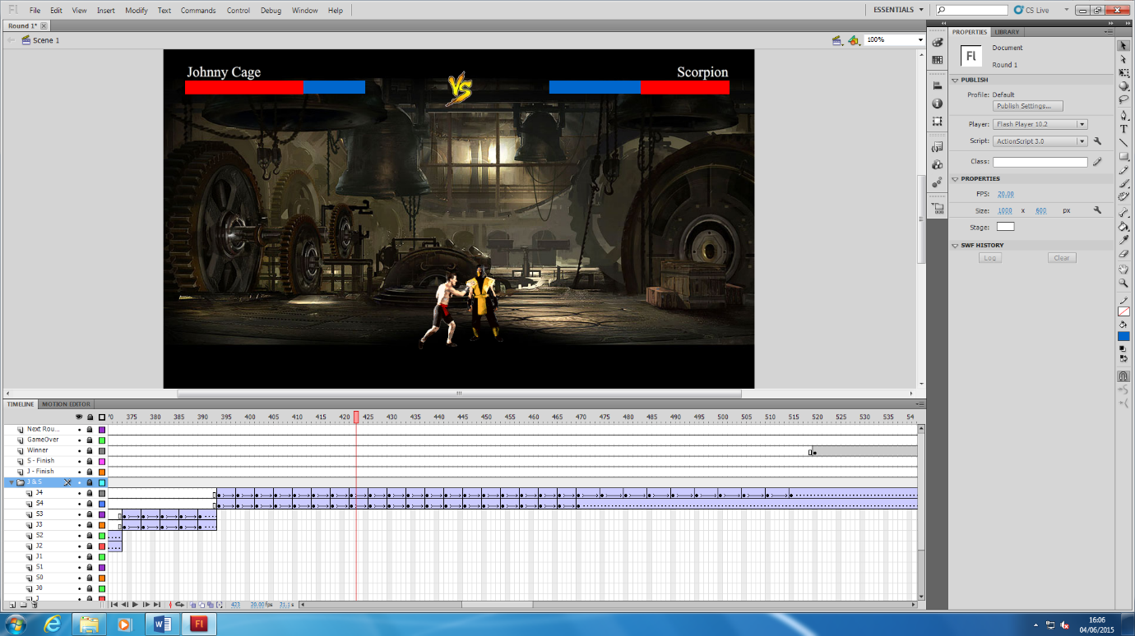

*Characters movements*

The characters movements will involves in the whole of this animation in different stages. When start and end of this animation, both characters are approach on the scream as still – none movements.

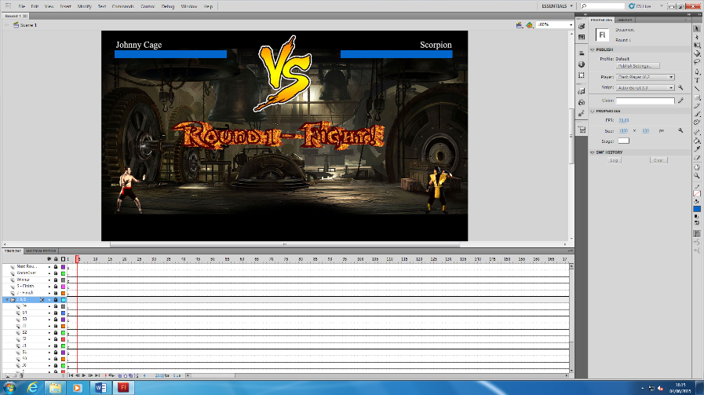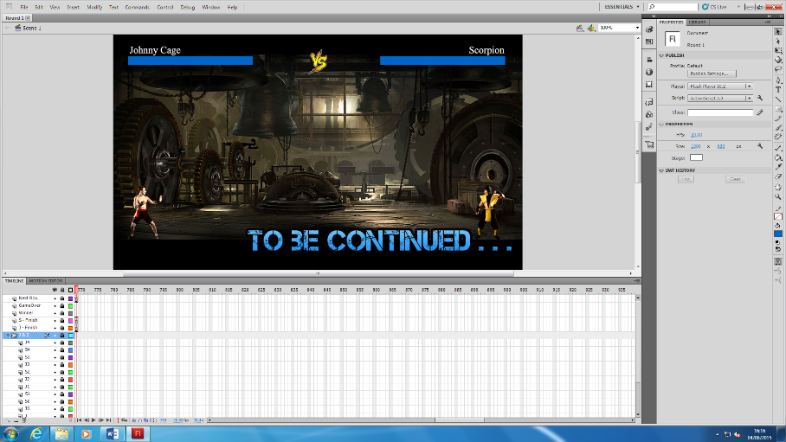

During the processing of this animation, both characters have different movements to fight each other, such as being hit, blocking, kicking, punching, walking getting up and victory pose.

# Walking

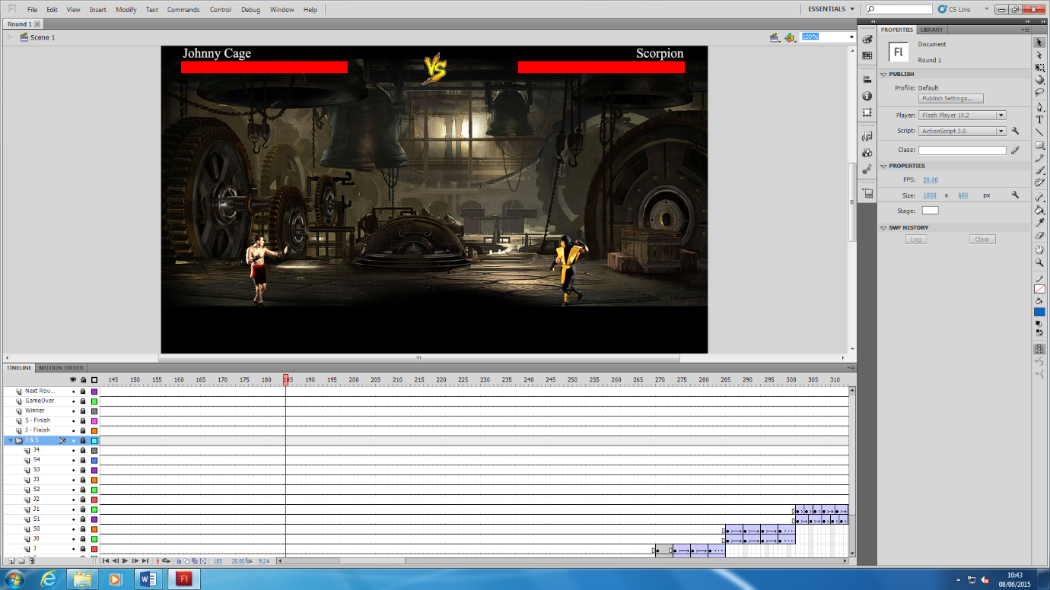

# Punching

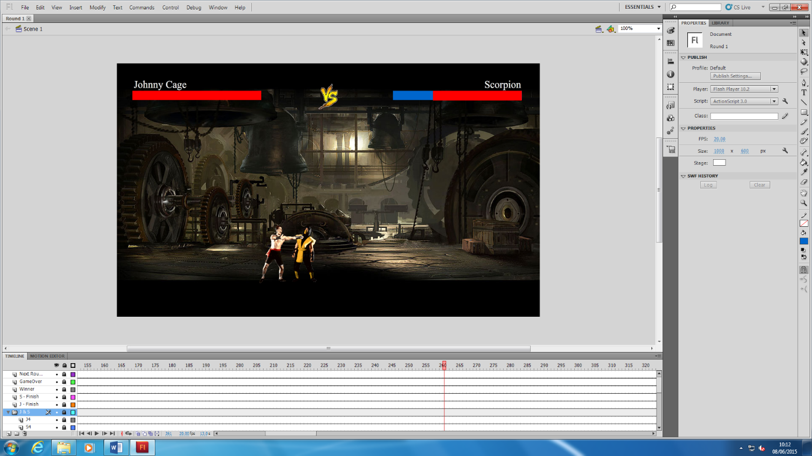

# Kicking

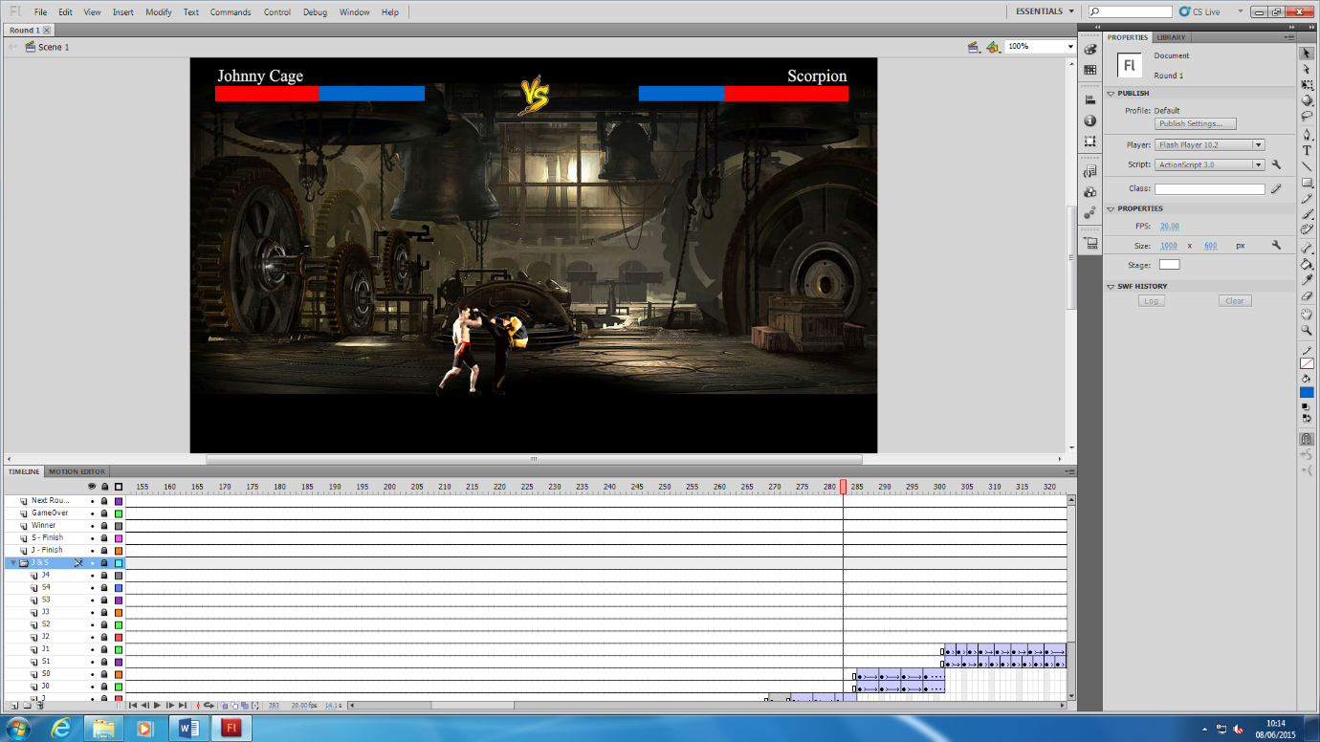

# Blocking

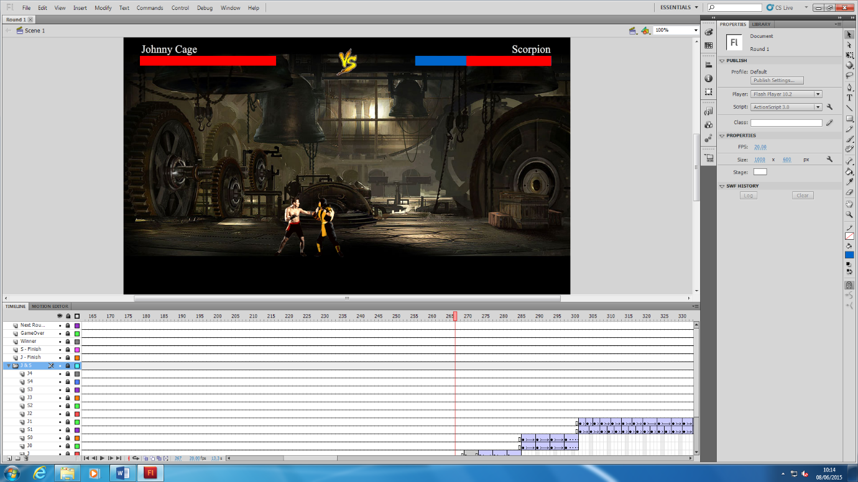

# Being hit

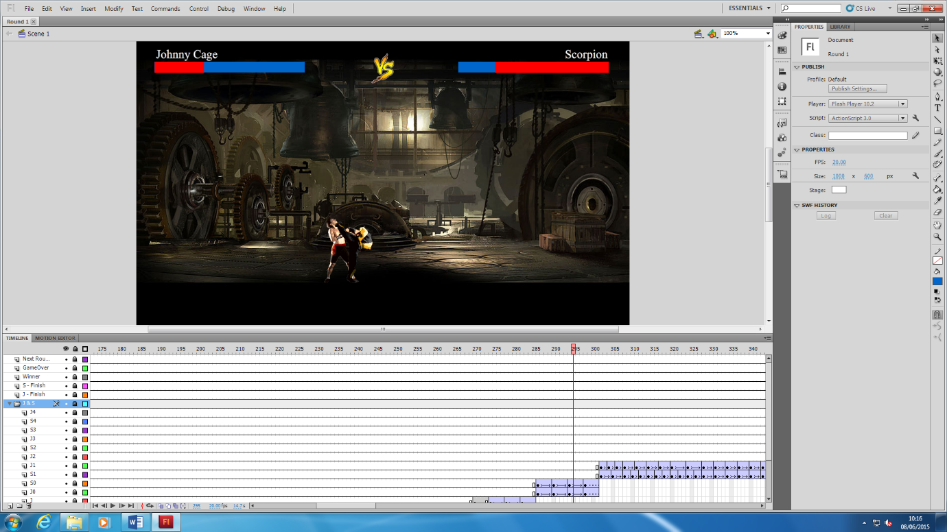

# Getting up

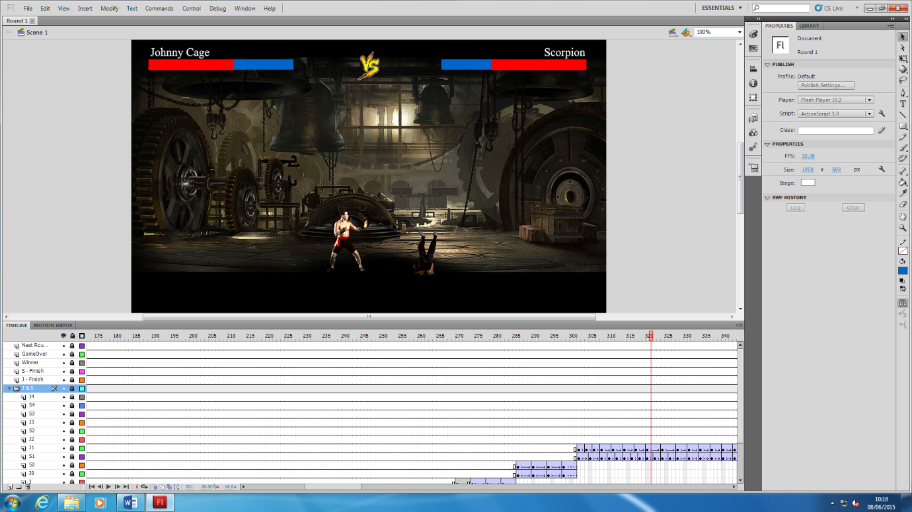

# Victory pose

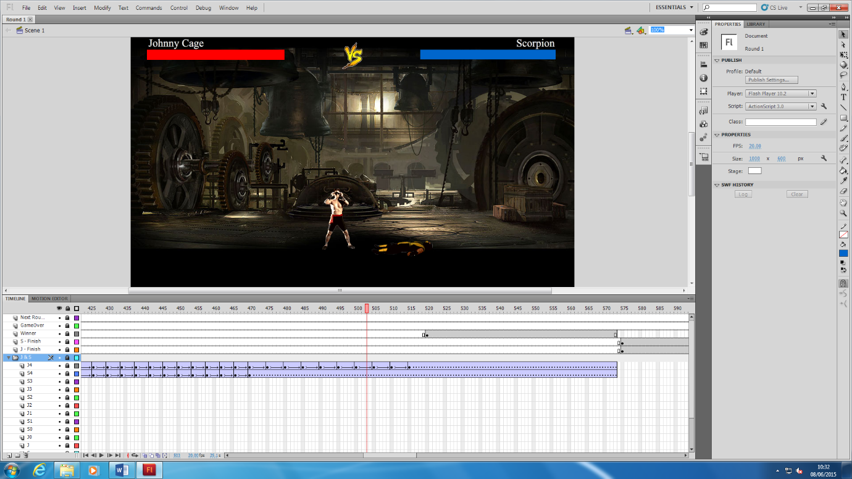

*The winner*

There will be a winner at the end of this animation and there will be a text to show the viewer of character.

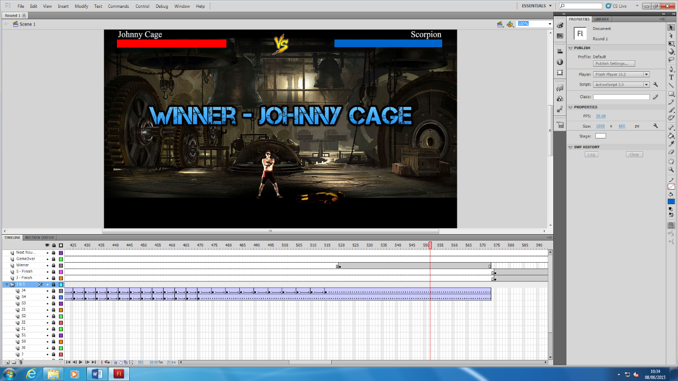

*Game Over*

Following the text of winner would be the text of game over for end this animation.

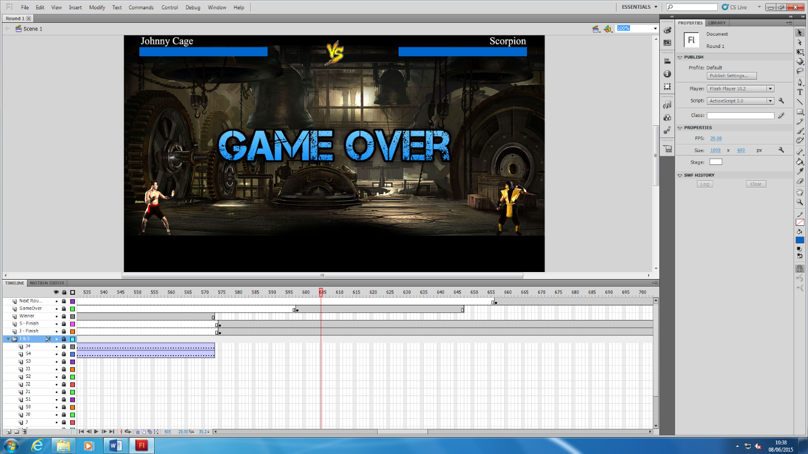

*The next step*

After the text of game over approached, there will be a text to show what is next thing could happen.

